State of California v. Superior Court of Ventura County (Paniagua)
(2022) DJDAR 4115
Where the circumstances are sufficiently “similar,” unredacted traffic accident investigative reports may be ordered to be disclosed to party with “a proper interest” in the identifying data contained in the reports.
FACTS: Moises Paniagua was driving northbound on Walnut Canyon Road approaching a left curve in the roadway at Broadway Road. Lisa Kinsey was approaching Walnut while traveling eastbound on Broadway. Kinsey allegedly failed to keep her vehicle in her lane of travel and struck Paniagua's vehicle, killing him. (See photo on next page.)
In 2019, the wife and minor children of Paniagua (Plaintiffs) sued Kinsey for negligence, as well as the City of Moorpark, the City of Ventura, and the State of California for a dangerous condition on public property (Gov. Code, § 835) and negligent or wrongful act or omission of an employee (id., § 815.2). Plaintiffs alleged: (1) before Paniagua’s accident, “other incidents of the same or similar type occurred at the same location as a result of vehicles crossing into opposing lanes of traffic and crashing into each other”; and (2) the site of Paniagua’s accident was a dangerous curve and/or a dangerous section of public roadway that Moorpark, Ventura, about which the State either knew or should have known.
PROCEDURAL POSTURE: During discovery, Plaintiffs propounded on Petitioner State of California ex rel. Dept. of Transportation (the State) voluminous written discovery, including special interrogatories. The interrogatories at issue (set two, Nos. 118 through 123) sought the names, addresses, and telephone numbers for all persons identified as parties or witnesses to the traffic accidents reported in the three redacted reports previously produced (for accidents in Dec. 2010, Mar. 2014, and Sept. 2015).
The State objected to the special interrogatories arguing, “The information requested is protected from disclosure by Vehicle Code § 20012.” Plaintiffs filed a motion to compel further responses on the ground that they have a “proper interest” in the contents of the related traffic accident reports, pursuant to the same section of the Vehicle Code cited by the State. Plaintiffs contended the facts of the three traffic collisions specified in the special interrogatories are similar enough to Paniagua’s accident to confer in Plaintiffs a “proper interest” in the unredacted copies of the corresponding accident reports, as per Veh. Code § 20012.
The Superior Court of Ventura County granted Plaintiffs' motion to compel further responses to the special interrogatories. It concluded that accident reports prepared by peace officers are not confidential under Vehicle Code § 20014, and, therefore, the confidentiality provisions of Vehicle Code § 20012 did not apply. The State’s petition for writ of mandate ensued.
HOLDING: State of California’s petition for writ of mandate is DENIED.
DISCUSSION: The Second Appellate District Court of Appeal held that Plaintiffs were persons with a “proper interest” in obtaining the unredacted traffic reports for purposes of Veh. Code § 20012 because the other three accidents were sufficiently similar to Paniagua’s. The evidence of the other accidents was either admissible in Plaintiffs’ suit or reasonably calculated to lead to the discovery of admissible evidence.
In its written opinion, the Court of Appeal relied extensively on Cal. ex rel. Dep't of Transp. v. Superior Court (1985) 37 Cal.3d 847 (Hall), in which the California Supreme Court stated that “Nothing in the language of §20012 excludes persons involved in other accidents from the class of persons with a ‘proper interest’ in the [unredacted] reports of a given accident.” And, said the court, “Plaintiffs are just such ‘persons involved in other accidents.’” Here, “the prior traffic accident occurred in the same location, under similar circumstances, and similarly resulted in serious injuries or death.” From these fairly generic and vaguely described facts of the accident underlying the instant case, the court fashioned “factors” for trial courts to look to decide whether a party has a “proper interest” in obtaining unredacted accident reports.

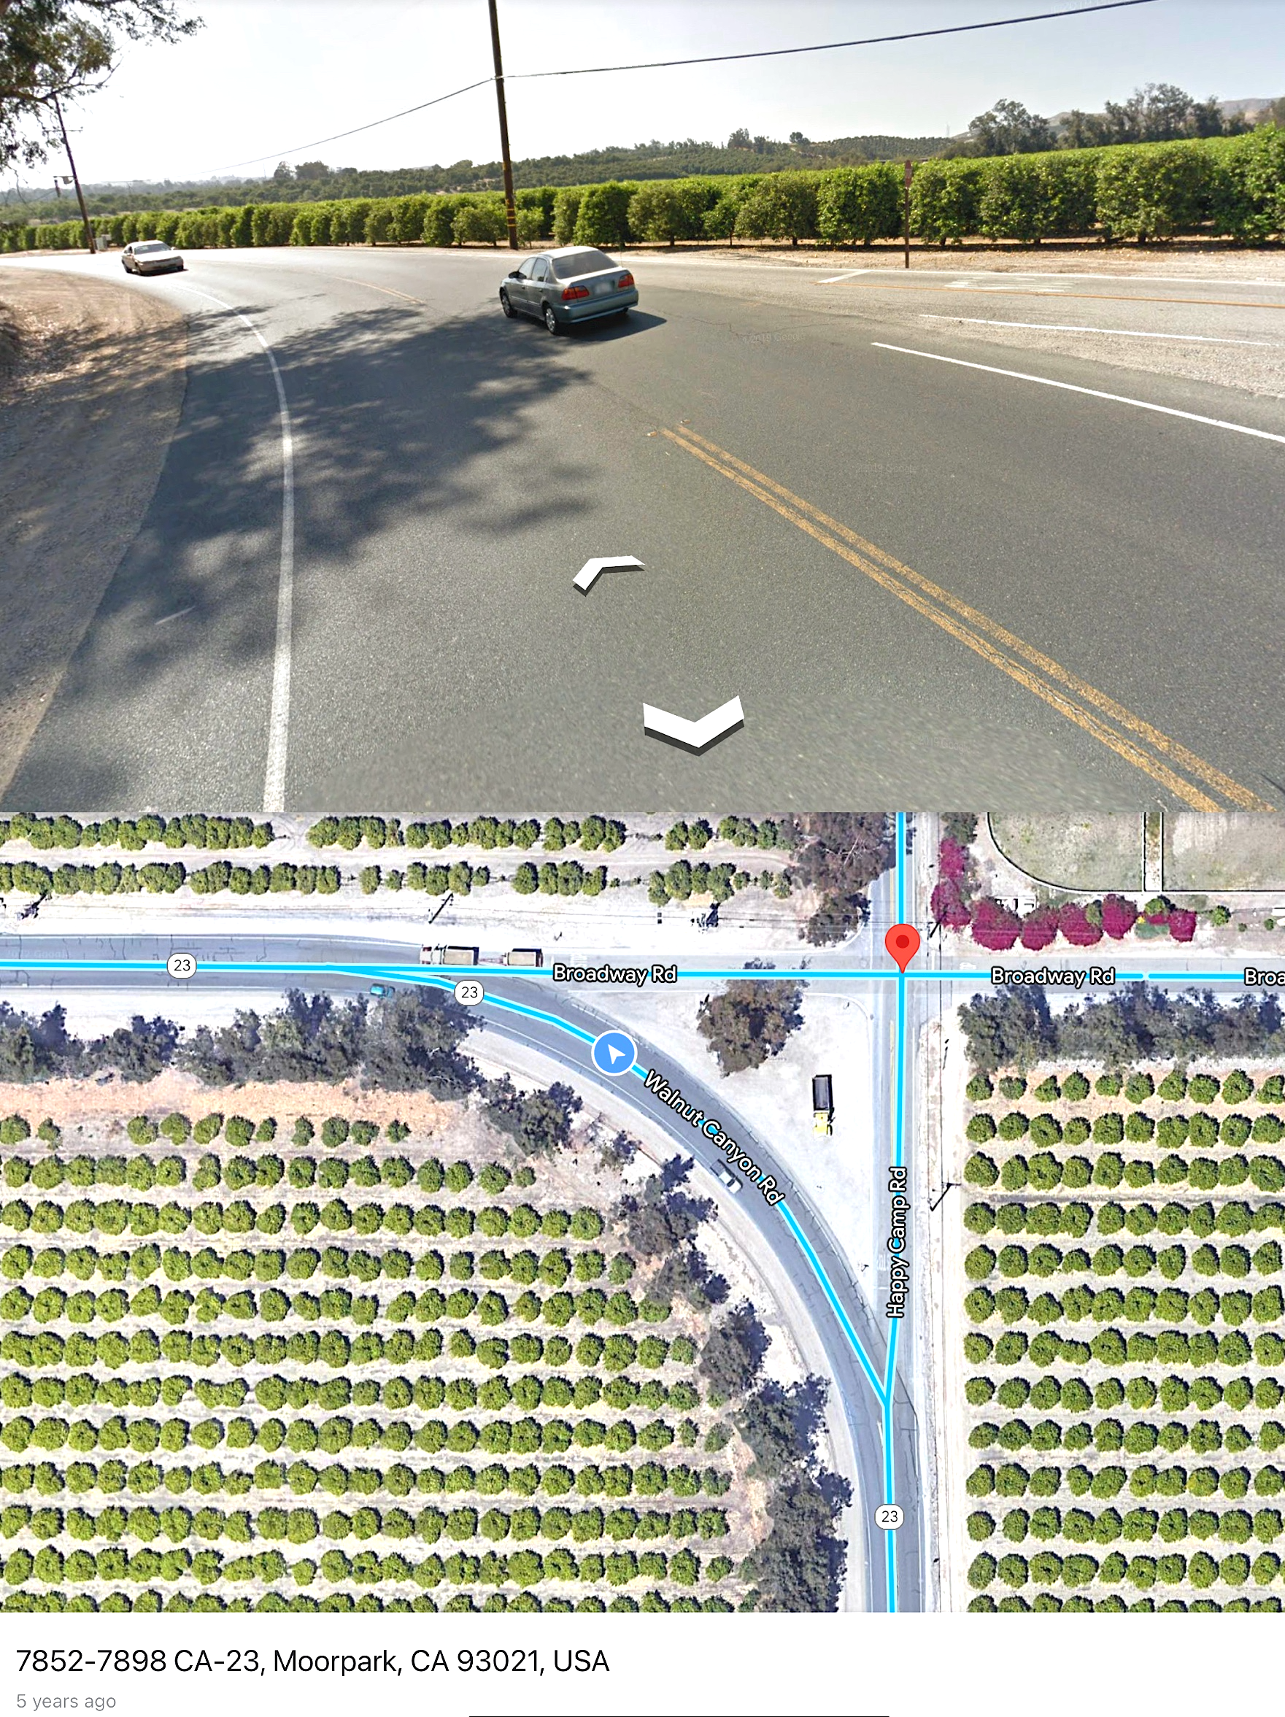

Decedent Moises Paniagua (Plaintiffs’ husband and father) was turning left along Walnut Canyon Road (depicted here) moments before another driver, while turning right off Broadway Road, strayed over the center lane, drifted into Paniagua’s lane, and collided head-on with Paniagua’s vehicle.

